**Shoes: Sport Chek**

Adidas Women's Grand Court Shoes - White/Core Black

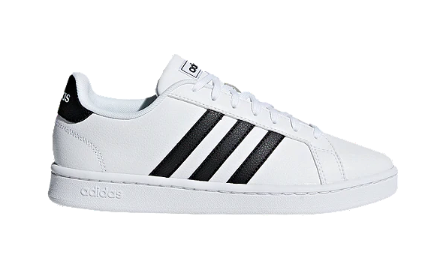

<https://www.sportchek.ca/product/adidas-womens-grand-court-shoes-white-core-black-332682522.html?gclid=CjwKCAjw_Y_8BRBiEiwA5MCBJrYP6E2qIGWFu517mn66jq2V_eritCiCNL_j6XHEarUSWu26cdITtBoCLN8QAvD_BwE&gclsrc=aw.ds#332682522=332682538>

**Pants: Forever 21**

Light blue utility cargo pants

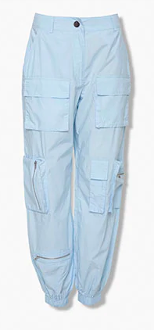

**Shirt: three trees**

Beige mini bra top

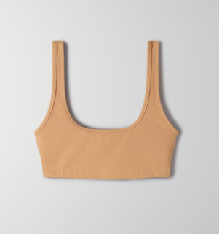

**Jacket: aritzia**

Super puff matt black jacket shorty

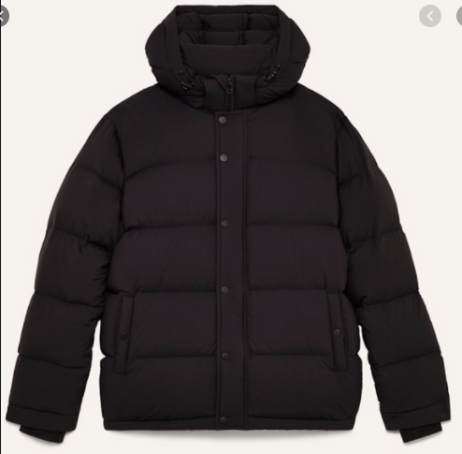

**Glasses: Walmart**

Round Shape Men Women Sunglasses Unisex UV400 Protective Eyewear Sunglasses

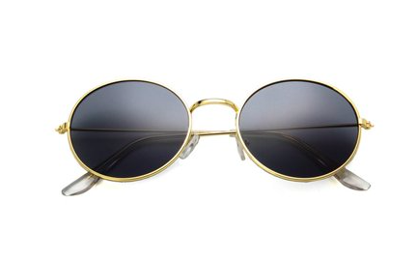

**Necklace: Forever 21**

ancient coin pendant layered necklace

